ERACLE project starts wind tunnel model manufacture for quieter aircraft configurations

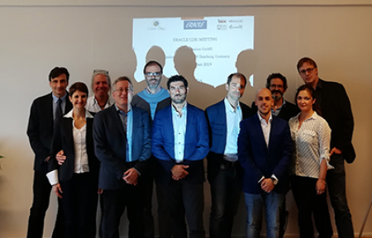

29 October 2019

Clean Sky 2’s ERACLE project, part of the Airframe technology platform, reached an important milestone on 10 October with the passing of the Critical Design Review (CDR) and the start of the manufacturing of the wind tunnel (WT) model. The aim of the ERACLE project is to perform wind tunnel tests to collect accurate data and use it to verify and validate a toolset to design aircraft configurations for better acoustic performance.

The ERACLE project is focusing on a pushing and wing mounted propeller-based propulsion. Pusher propellers are highly efficient at higher speeds, but this results in loud noise production. Therefore the installation of these pusher propellers is critical: installation at certain distances on the wing, or at certain proximities to the fuselage, can lead to various effects on the noise produced (near- and far-field). So a good knowledge of the acoustic propagation is essential, in order to determine which configurations are better suited to reduce noise: and this is where the ERACLE project comes in!

The ERACLE consortium has now completed the design of the WT model, which will include innovative design features such as new sets of propeller blades, hub, spinner, fairings, shaft and suitable mechanisms for varying the propeller installation configuration; and a complete hardware/software system comprehensive of an electrical motor to drive the propellers.

Planned to start in June 2020 in the acoustic large low speed wind tunnel of Pininfarina (the subcontractor of ERACLE for WT test services), the test campaign will look at installation configurations and the different kinds of aerodynamic flows generated by the wing through controlled boundary layers. This will enable the project engineers to collect and post-process WT test data in terms of near-field and far-field acoustic propagation, as well as to further develop and validate a fast engineering toolset for the preliminary design of propeller-wing arrangements vs. acoustic performance.

Partners in the ERACLE project are: IBK for Coordination and WT model design; NHOE for WT model systems design leader; UNIROMA3 for acoustic pre-design toolset and WT test campaign management; and Eligio Re Fraschini (ERF) for WT model manufacturing, instrumentation and implementation in the WT. The Topic Manager is Airbus Defence and Space.